**Profiler Screenshots**

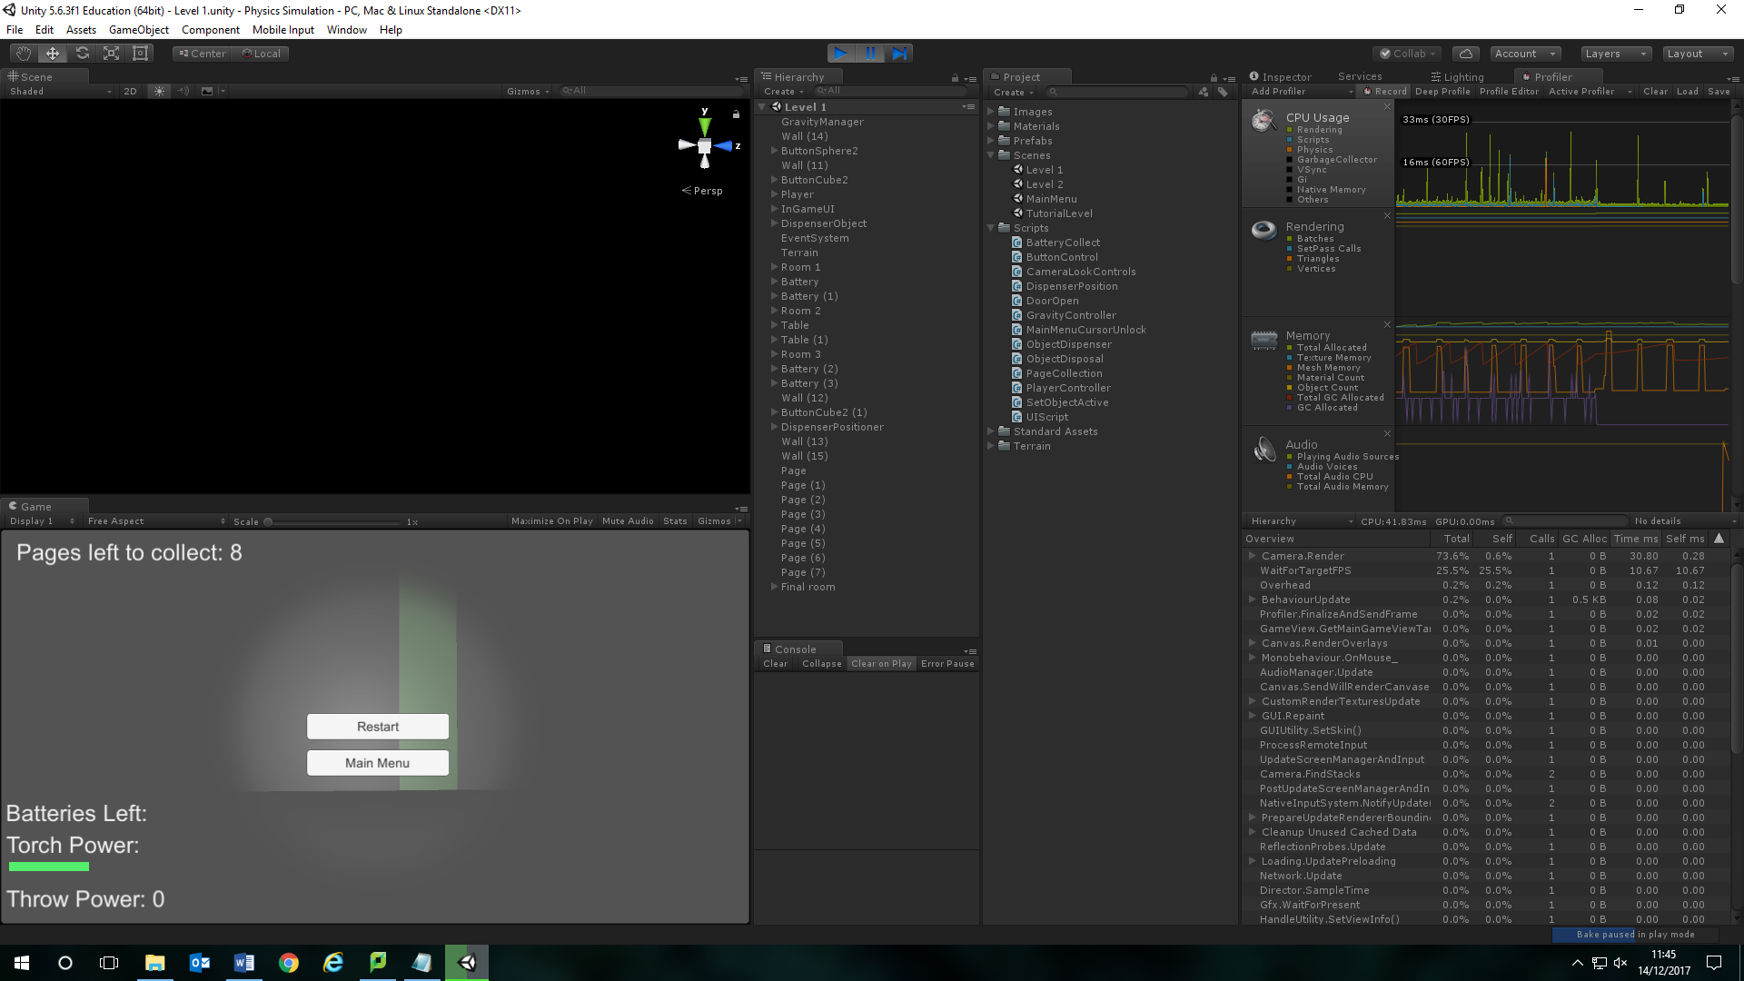

Here I’m using the profiler to detect where I need to optimise for my game to run better and not use up unnecessary CPU.

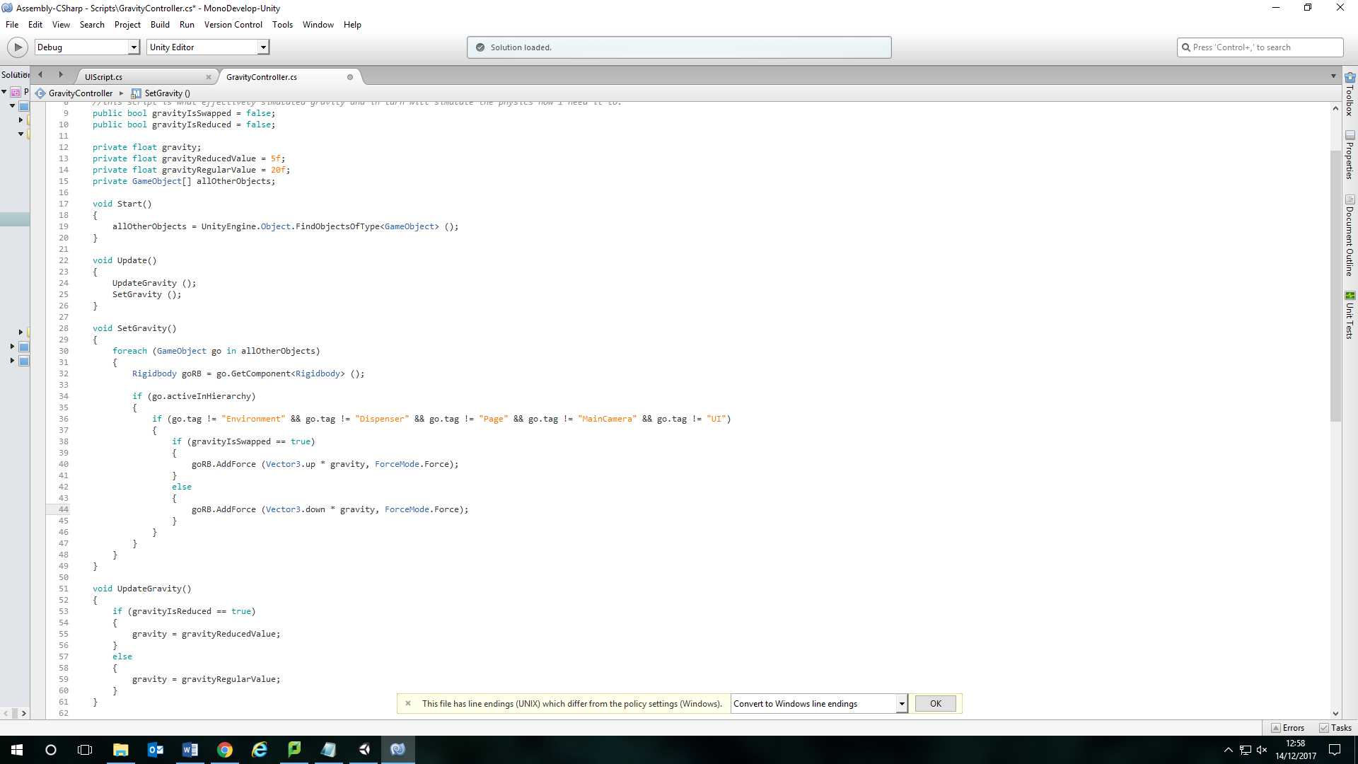

I have attempted to change parts of the script in my gravity script, however, I have found that, for objects already in the scene, the gravity will work fine. But for any object that I spawn into the scene afterwards doesn’t have gravity applied to it. So it just floats off into space. This was to try to make better use of CPU using the profiler.

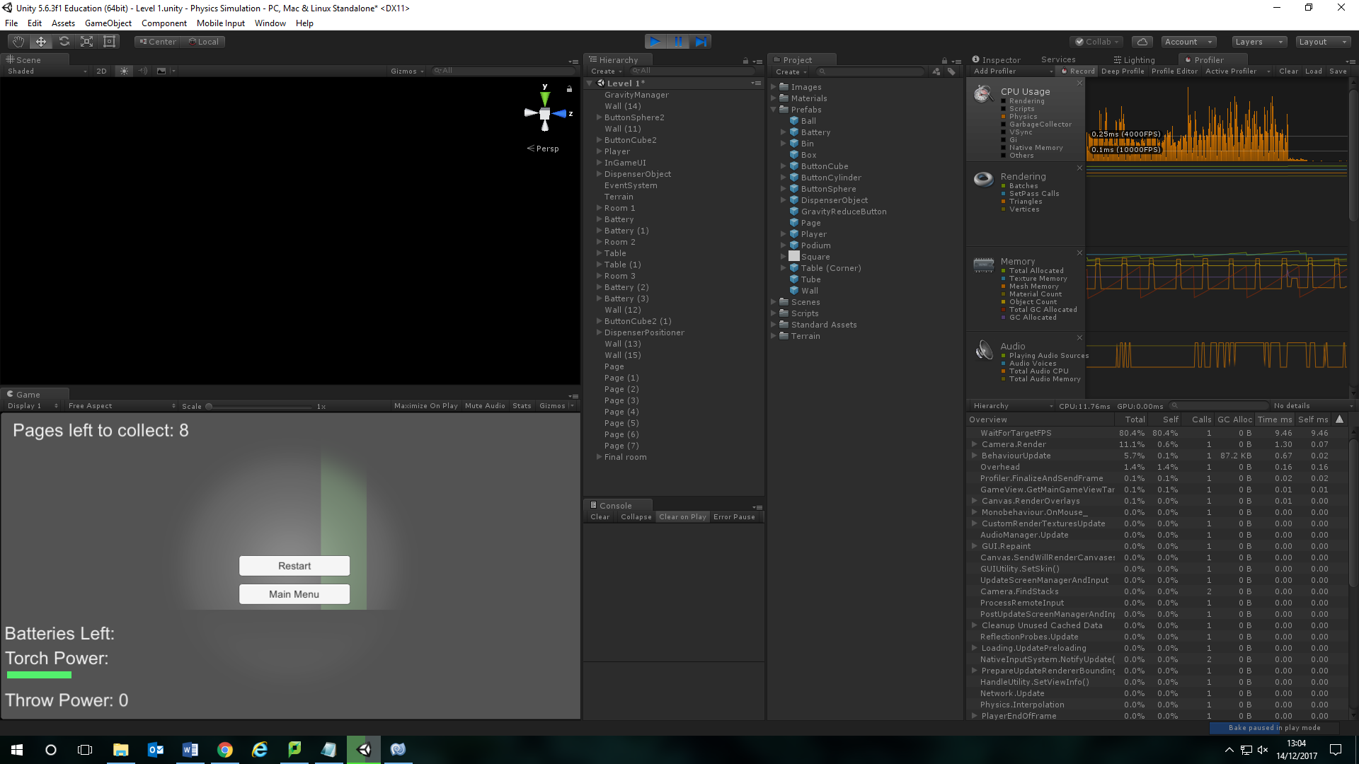

Here is a screenshot of the profiler after using the updated script.

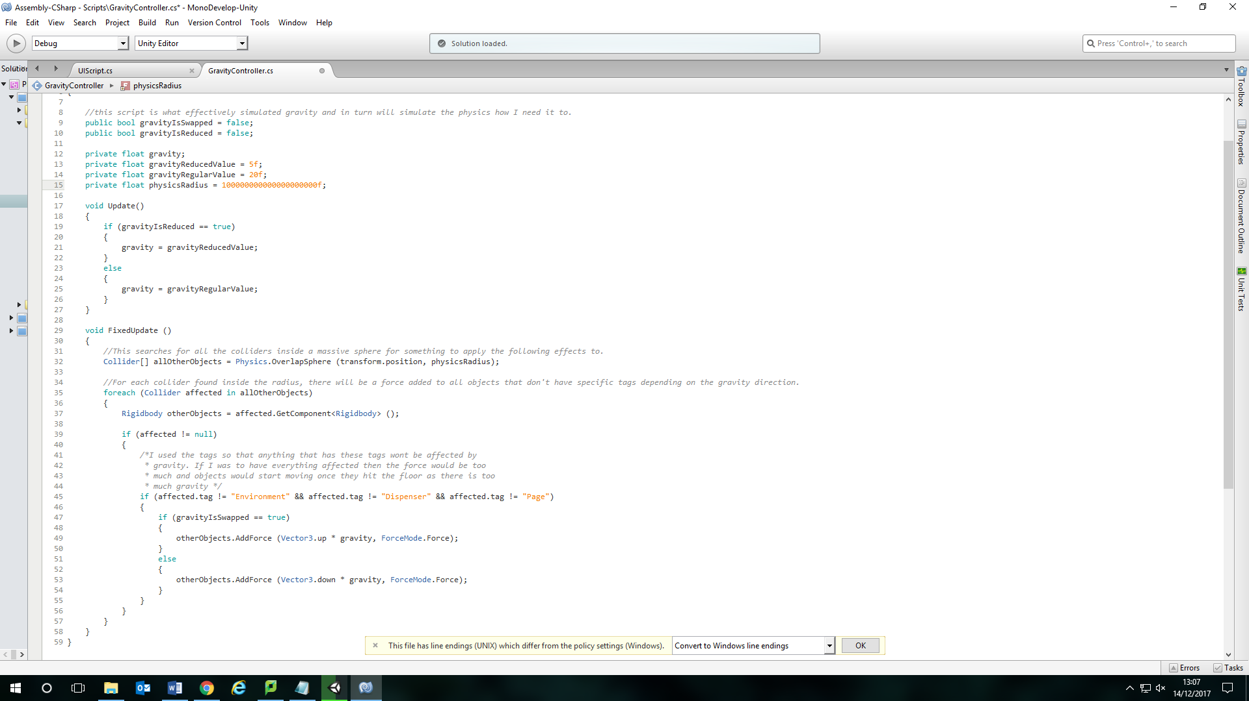

For now, using the results from the profiler, I will be reverting back to the older script as it seemed to work a little better.

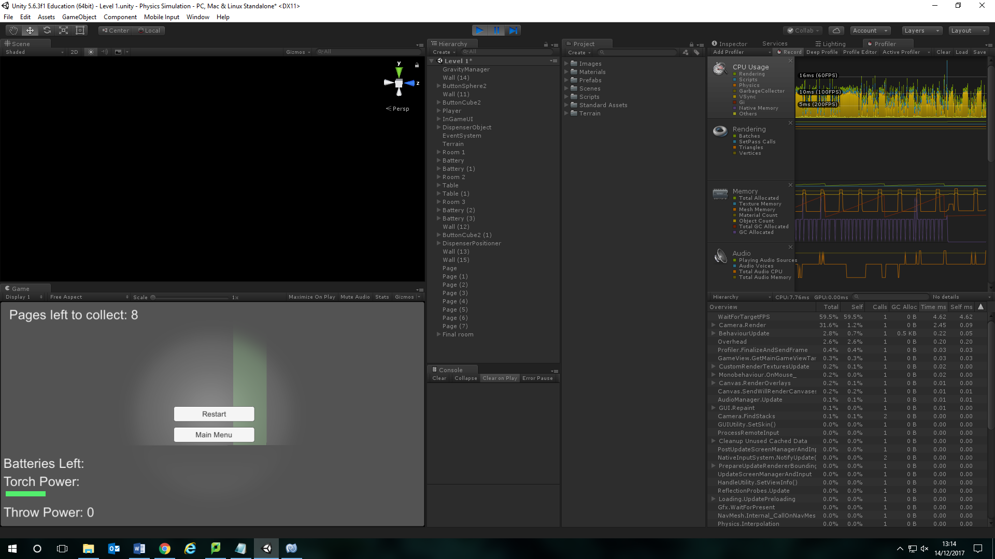

Here is another screenshot of the profiler checking what I could do to optimise it.

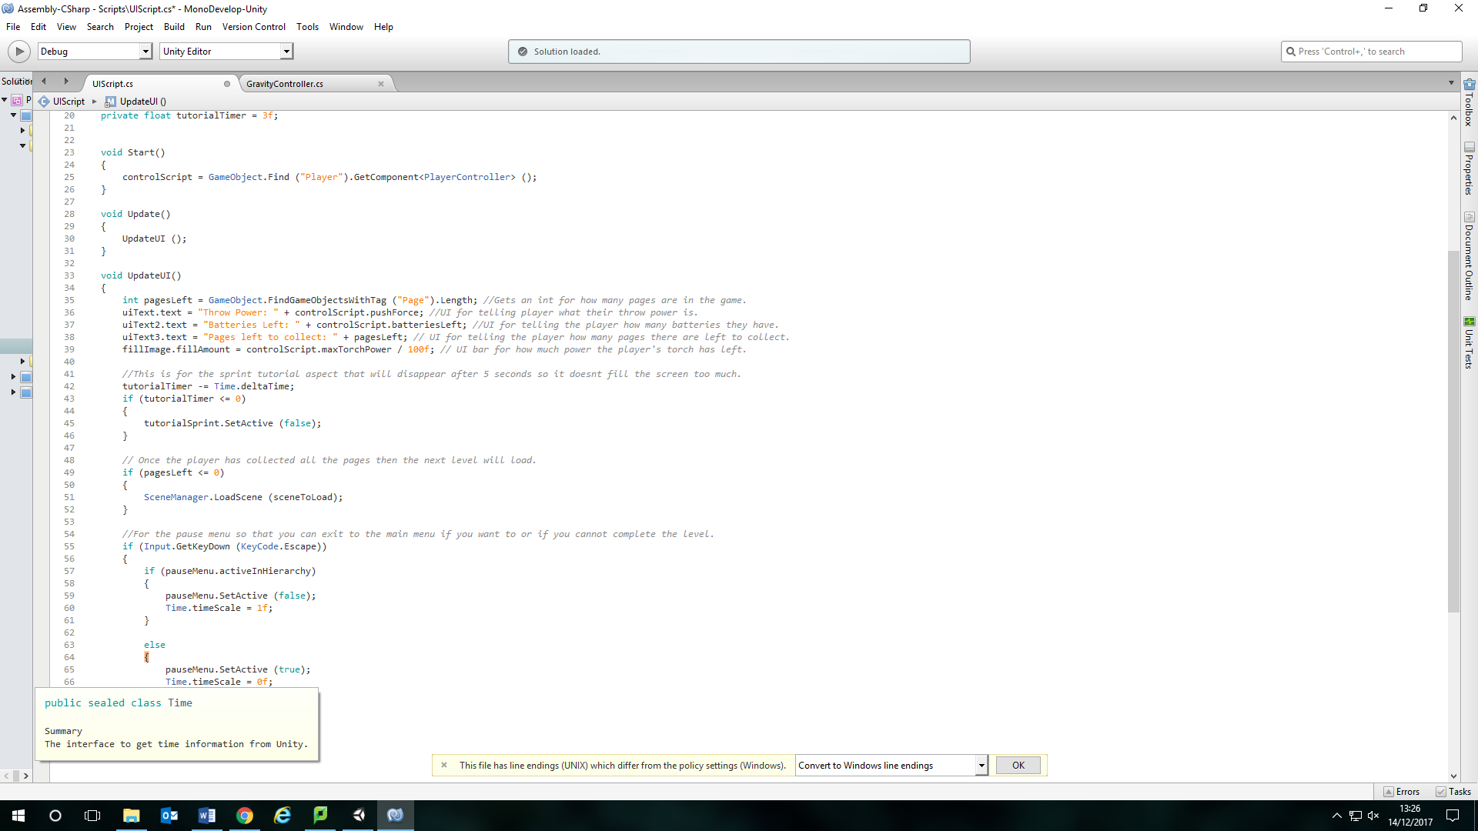

For now I have updated my UI script so that it isn’t just using update for the UI. I’m using a separate method for updating the UI but that method is called in Update.